Brandon Douglas, Isaac Burns, Thomas Umscheid, & Robert (Luke) Schnefke

Dr. Derby

Heat Transfer, ME 573

8 May 2015

Analyzing Different Working Fluid and Geometric Heat Exchanger Designs

**Introduction**

Our team was tasked with designing a pre-condenser. This heat exchanger must be capable of providing a wide range of steam qualities to a testing environment. To complete this task, we analyzed multiple combinations of fluids and heat exchanger geometries, we calculated the range of possible qualities of our chosen design, and we estimated the uncertainties in our measurements.

**Design**

We began designing our pre-condenser by selecting two fluids and three heat exchanger geometries. Then, we compared each fluid and each geometry. Finally, we selected a fluid and geometry combination.

First, we selected water as one fluid because of its high saturation temperature at low pressures, and the ease of calculating water’s properties. As the second fluid, we selected engine oil. Engine oil also has very high saturation temperature over a wide range of pressures, it is also easy to locate properties of this fluid.

Next, we decided to use a parallel flow heat exchanger as a baseline comparison. The parallel flow heat exchanger is certainly not an ideal design, but it will make for quick initial calculations. To improve performance, we chose a concentric counter flow heat exchanger and a shell and tube heat exchanger. Both of the configurations will be more efficient than the parallel flow, although they are more complicated.

Finally, we compiled a table of possible fluids and a table of possible heat exchanger geometries. In the tables, we compare the advantages and disadvantages of each possibility.

|  |  |  |
| --- | --- | --- |
| **Fluid** | **Advantages** | **Disadvantages** |
| **Water** | Conditions are well known and easy to calculate. | Low saturation point at standard conditions. |
| **Engine Oil** | Very high saturation point at standard pressure. | High viscosity at standard conditions. |

|  |  |  |
| --- | --- | --- |
| **Geometry** | **Advantages** | **Disadvantages** |
| **Parallel** | Easy to analyze and construct. | Lower efficiency than other designs. |
| **Counter Flow** | Efficient for small scale applications. | Requires a longer length than other configurations. |
| **Shell and Tube** | High heat load capability. | Difficult to implement for small flow rates. |

Based on the results of our analysis, we chose to use water in a counter flow heat exchanger. We believe that low viscosity of water and efficiency of the counter flow geometry will allow our pre-condenser to output the best range of qualities.

**Performance**

Next, we analyzed the performance of our pre-condenser. Our goal was to determine the range of possible steam outlet qualities. Below are the steps of our detailed performance analysis

1. We began by defining the known properties of the hot fluid. We were given steam at 20 degrees Celsius above saturation. For the given pressure of 35 psi, this was 420 degrees Kelvin. Using the given inlet temp (420 K) and pressure (241 kPa) we could find the inlet enthalpy (hi) using the superheated steam tables. The outlet temperature (Tho) is equal to the saturation temperature of steam. Also listed are the other two enthalpy values for this saturation temperature, hf and hfg, which will be used to find the quality.

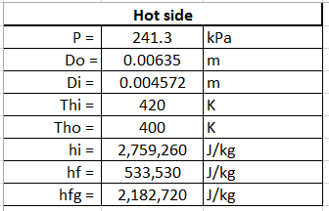

1. Next we made assumptions for the cold side. For both fluids, engine oil and water, we chose an inlet temperature (Tci) that would keep its outlet temperature in the single phase region. The remaining properties were found from the appendix tables, A.5 and A.6 respectively.

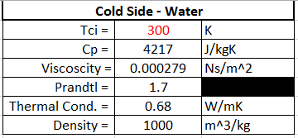

1. As seen in the design section, we implemented a counter flow heat exchanger. To simplify our design variables, we chose to keep the heat exchanger diameter the same as the incoming pipe.

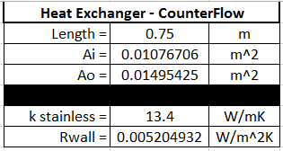

1. To start our analysis, we assumed a cold flow rate. After we completed the calculations, we tested multiple cold flow rates until we achieved a wide range of outlet qualites. The Reynolds number (Rec) was calculated using Equation 8.1. Since the Reynolds number is less than 2300 the Nusselt (Nuc) is 4.36 from Equation 8.53. Next, we calculated the heat transfer coefficient (hc) from Equation 8.69. Finally we were able to calculate the UA product from Equation 11.1a. The hot side heat transfer coefficient will be high enough where we can neglect it in the equation above. The wall thermal resistance (Rwall) was calculated using Equation 3.33.

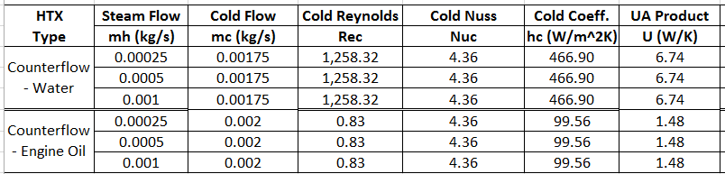

1. The minimum heat capacity rate (Cmin) will be that of the cold side, because the hot fluid is two phase. Cmin was calculated by multiplying the cold specific heat capacity by the cold mass flow rate. The number of heat transfer units (NTU) can be calculated from Equation 11.24. From the NTU relations found in Table 11.3 and for Cr = 0, we can calculate the effectiveness from equation 11.35a. From Equation 11.19 we can calculate the actual heat transfer (qact), using Equation 11.18 to calculate the max heat transfer rate (qmax). Next, using Equation 11.7b, we can calculate the cold outlet temperature (Tco). The hot side outlet enthalpy (ho) can now be calculated using the energy balance, qcold=qhot. Finally, from the two enthalpies and the superheated steam tables, the quality can be calculated.

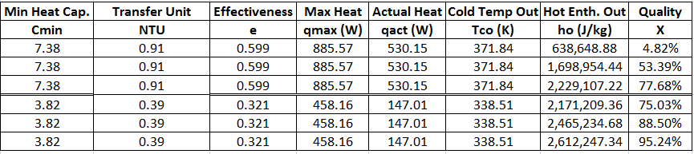

1. The Quality vs. Flow Rate graphs for both water and engine oil are shown below. Our analysis points towards using water as our cooling fluid because it gives us a wider range of qualities.

**Experimental Uncertainties**

To conclude the design process, we calculated the uncertainties that would be associated with our design. Uncertainties were calculated for a flow rate of 0.5 g/s of steam and an exit quality of 0.5 using water as our cooling fluid.

Heat duty is defined as the amount of heat needed to transfer from a hot side of a heat exchanger to a cold side of a heat exchanger over some period of time. Considering that the hot heat transfer rate and cold heat transfer rate are equal to each other, you could use either heat transfer rate for calculating the heat duty for a heat exchanger. However, for calculating the heat duty for this design project, you must use the cold side heat transfer rate as your cold temperature out is one of the measured values that you solve for in the design project. It is also a lot easier to solve using the cold heat transfer rate equation as there is no phase change on the cold side of the heat exchanger. Therefore, you will use the following equation:

$$q_{c}=\dot{m}×c_{p}×(T_{o}-T_{i})$$

Using this equation, we are able to calculate the heat duty of the heat exchanger that we designed. In addition, you will be able to use this equation when determining the propagation of uncertainty technique for our experimental uncertainties.

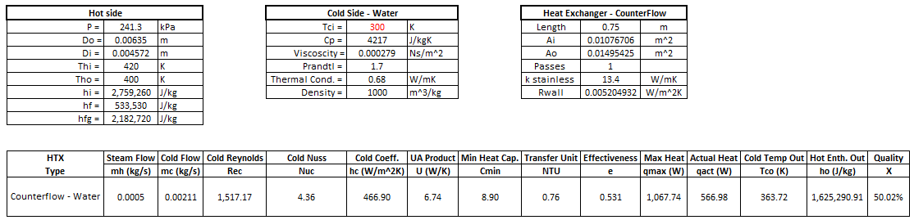

We were given the problem to solve for heat duty measured within ± 10% with a steam mass flow rate of 0.0005 kg/s and a pre-condenser exit quality of 0.5. The following results were found: Using these results that we found during the previous performance steps to ensure our exit quality for the pre-condenser would be around 0.5, we found that the best cooling fluid mass flow rate was:

$$\dot{m}= 0.00211 \frac{kg}{s}$$

For all of our uncertainty measurements, we decided to use a 99% confidence level for our measurements. The equation that we will use for the uncertainty numbers will be as followed with respect to each variable:

$$U_{\dot{m}}=± 1\% × 0.00211 \frac{kg}{s}$$

With this cooling fluid mass flow rate, we determined the uncertainty of the mass flow rate to be:

$$U_{\dot{m}}=± 0.0000211 \frac{kg}{s}$$

To find the cold specific heat capacity, we had to estimate the number given the cold temperature in and knowing that the cold temperature out would be warmer than the inlet temperature. Our cold specific heat capacity was estimated to be:

$$c_{p}=4.217 \frac{kJ}{kg∙K}$$

The uncertainty related to this cold specific heat capacity of water was:

$$U_{c_{p}}=± 1\% × 4.217 \frac{kJ}{kg∙K}$$

$$U_{c_{p}}=± 0.04217 \frac{kJ}{kg∙K}$$

The cold temperature entering our heat exchanger and cold temperature exiting our heat exchanger are calculated to be:

$$T_{o}=363.72 K$$

$$T_{i}=300 K$$

We were able to determine our uncertainties related to temperature measurements is around the following:

$$U_{T_{o}}=± 1\% × 363.72 K$$

$$U_{T_{o}}=± 3.6372 K$$

$$U_{T_{i}}=± 1\% × 300 K$$

$$U_{T_{i}}=± 3 K$$

These were the values that we either calculated or found through research from different sources that we will be able to use when determining if our heat duty can be measured within ± 10%.

The next step of the process is calculating the uncertainties related to the heat duty. In order to accomplish this through the propagation of uncertainty technique, you must use the equation for heat duty given earlier:

$$q_{c}=\dot{m}×c_{p}×(T_{o}-T_{i})$$

You will need this equation as you will calculate the heat duty with it like previously stated. Plugging the values that we gave into the equation you come up with:

$$q_{c}= 0.00211 \frac{kg}{s} × 4.217 \frac{kJ}{kg∙K} × (363.72 K-300 K)$$

This results in a total heat duty of:

$$q_{c}=567.0 W$$

The heat duty equation will also be used to help with the heat duty uncertainty as you need to solve for partial derivatives. The equation for the heat duty uncertainty is as followed using the propagation of uncertainty technique:

$$U_{q_{c}}=±\sqrt{{(\frac{∂q_{c}}{∂\dot{m}}×U_{\dot{m}})}^{2}+{(\frac{∂q_{c}}{∂c_{p}}×U_{c_{p}})}^{2}+{(\frac{∂q_{c}}{∂T_{o}}×U_{T_{o}})}^{2}+{(\frac{∂q_{c}}{∂T_{i}}×U_{T_{i}})}^{2}}$$

Partially deriving the equation given, you determine:

$$U_{q_{c}}=±\sqrt{{{(c_{p}×\left(T_{o}-T_{i}\right)×U_{\dot{m}})}^{2}+{(\dot{m}×\left(T_{o}-T_{i}\right)×U_{c_{p}})}^{2}+(\dot{m}×c_{p}×U_{T_{o}})}^{2}+{(-\dot{m}×c_{p}×U_{T_{i}})}^{2}}$$

Once again, plugging in the different values that we determined through calculations and research, the following is found:

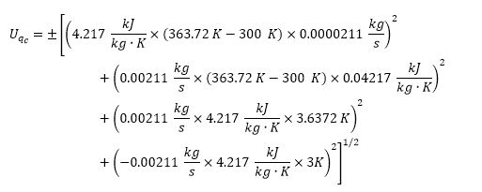

Solving for cold heat duty uncertainty you find:

$$U_{q_{c}}= ± 42.7 W$$

Lastly, to ensure that the heat duty is within a relative uncertainty of ± 10% of the measured quantity, you use the following equation:

$$u_{q_{c}}= \frac{±{ U}_{q_{c}}}{q_{c}}×100$$

This comes to:

$$u_{q_{c}}= \frac{± 42.7 W}{567.0 W}×100$$

So the final relative uncertainty of the cold heat duty is:

$$u_{q_{c}}= ± 7.53 \%$$

This falls inside our parameters of a heat duty measured within ± 10% with a steam mass flow rate of 0.0005 kg/s and a pre-condenser exit quality of 0.5.

**Conclusion**

We believe that a concentric counter flow heater exchanger using water as a cooling fluid will satisfy the requirements of this pre-condenser. We have shown that our design can produce an acceptable range of output qualities. In addition we have shown that the uncertainties for our design our within 10% of the total heat duty.xperimental