|  |
| --- |
| John Annan, Tanner Lott, Shane Smith, Hayden Thull, Thomas Umscheid  5-6-2015 |

Design Review #4

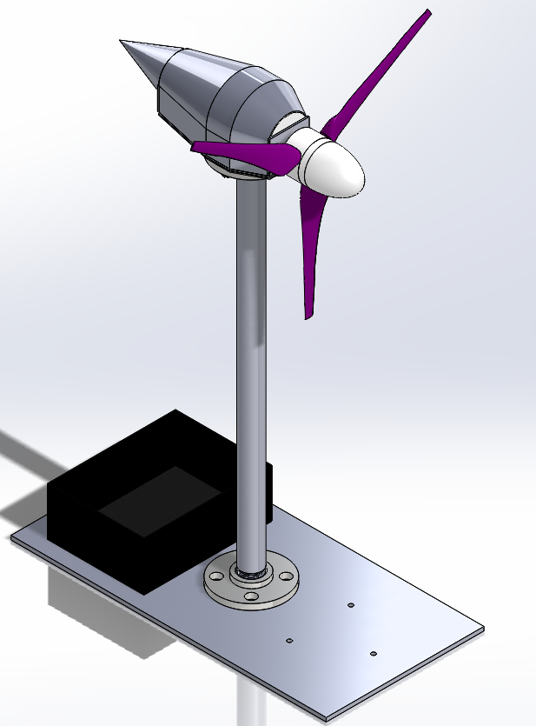

Contents

Semester and Competition Goals 2

Gearbox 2

Structure Rebuild 3

Wind Tunnel Testing 5

Competition Results 6

Lessons Learned for the Future 7

Budget 9

Semester and Competition Goals

When we started this semester we had a rough design for the whole turbine. Our focus was to fully assemble and test our design, then make modifications as necessary. During this whole process we would finish documenting our process, make tutorials for software, and make recommendations for the future team based on what we had learned.

For competition we were mostly aiming at the maximum power amount. The electrical team’s brake was not working, so we knew we couldn’t get those points. We also didn’t think we could get the cut-in part of the points since we had to add a gearbox. However we were confident our turbine would survive the durability tests intact.

Gearbox

During initial wind-tunnel testing we found that using direct drive didn’t allow us to use all of the generator’s potential for making power. After putting the generator on a dynamo and checking the power that came out, the electrical team recommended that we go with a 2:1 gearbox to allow us to maximize our power with the generator.

We started by trying to find commercially available gearboxes. However, the ones we found were either too expensive or didn’t meet our required specifications (RPM operating range, gear ratios, external power requirements, etc.). Time was also an issue, many of the commercially available options would not have arrived until after competition. Because of this, we decided to build our own gearbox in house using commercially available gears.

The junior ME team had found good bearings at a local hobby store (Cattown Hobby), so we went there to order gears and bearings for our gearbox. We were able to select two gears (14 teeth & 29 teeth) that gave us a 2.07 gear ratio with the same pitch and that fit on a 5 mm shaft. We also ordered sets of bearings to support all the gearbox shafts and a coupler to work between two 5 mm shafts. The modeled gearbox is shown with all major components labeled in Figure 1.

Graphite was used to reduce friction and it made a big difference. It was difficult to apply and keep applied, but it substantially reduced the meshing resistance of the gears. Although we did not have time to construct a test to numerically demonstrate its effect, it was noticeable and we recommend using Graphite in the future.

Figure : Gearbox Components and Layout

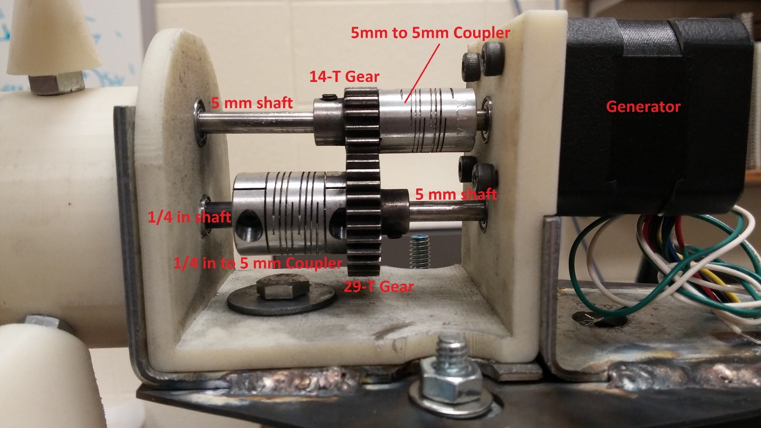

There are bearings inset for each end of the shafts to allow support and free rotation. Each of the gears has a set screw to keep it on the shaft. We have successfully built and tested this gearbox.

Structure Rebuild

Our first structure design was too bulky and interfered with airflow. So our goal was to redesign it to not interfere as much with airflow while retaining the structural rigidity. That rigidity prevented any vibrational issues.

While coming up with the design we realized that we were limited in how well we could machine metal components, so we decided to use commercially available parts to improve the accuracy and reduce the time required to assemble our design.

Figure : Top Structure Components and Layout

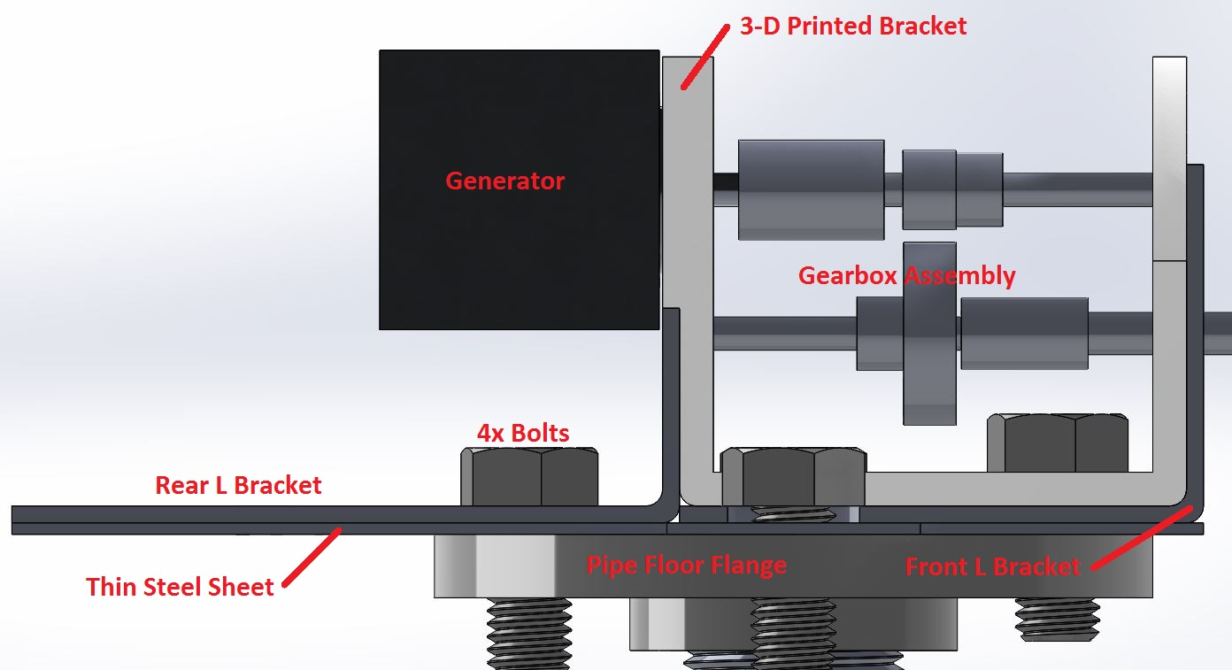

In Figure 2 we see the components of the top portion of our structure. The half inch diameter pipe the junior ME team had used for their tower had vibrational issues, so we chose a one inch diameter for our design, which prevented us from having to use guide wires. Our goal with the top structure was to make the assembly as small as possible while making use of pre-fabricated parts and sufficient tool room for easy assembly/disassembly. We decided to use a combination of two metal L brackets and a thin sheet of steel to mount our generator and gearbox to the pipe. This allowed us to use pre-made parts with only slight modifications.

Vibration was a major concern for us throughout the design process. In the wind tunnel testing we had noticed the junior ME team’s 3-D printed bracket flexing during loading, so we designed our structure to have metal supports to bear the load to avoid that issue.

This design was made very quickly and we discovered several problems when we assembled it and tested it. The standard specifications for the pipe flange did not match the dimensions of the real part, so our holes were too large and not in the same locations. The press fit for the bearings worked well for all but one of the bearings, which came loose at competition. Only using one bearing for each shaft in the gearbox allowed the shafts to flex in the helical couplers, causing the blade and hub assembly to wobble noticeably in the wind tunnel. Finally, because we had to weld the L brackets to the thin steel sheet, we were unable to mount our Nacelle design to the tower.

Figure : Nacelle and Nacelle Base Design

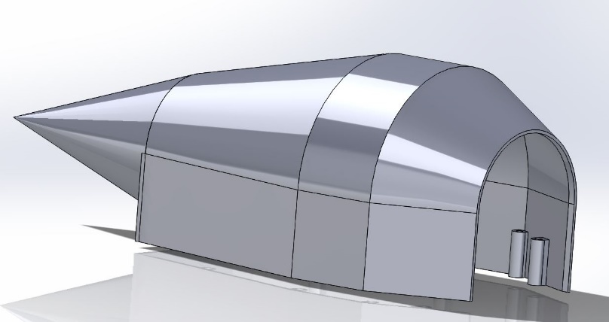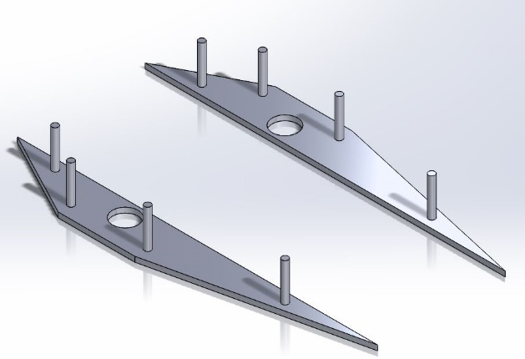

In Figure 3 we have the two parts of our Nacelle design. The goal was to enclose the components in a drag reducing and aesthetically pleasing way. We printed both parts, but the pins were too fragile and the weld beads prevented us from mounting the two base pieces. Other methods to attach the Nacelle to the top structure were considered, but we ran out of time to implement any of those ideas.

The final piece in the structure redesign was the electrical box. We were informed that our initial designed box was too large. In our redesign we welded four rectangular pieces of metal to the base to hold a plastic box for the components. This worked well, but at competition we ended up not using the box at all due to the constraints of the wind tunnel and the electrical hookups used.

Wind Tunnel Testing

Before competition we were able to test our new design in the wind tunnel at the wind erosion lab. During the test we were able to make 9 Watts before a problem in the electrical circuit forced us to stop testing. A wire came loose and prevented us from reading RPM. The results from the test are given in Table 1.

Table : Senior Design from Wind Erosion Lab Testing



Figure : Senior Design Wind Erosion Lab Power Curve

This was a very successful test for us. We were able to fully test our assembled turbine over a wide range of airspeeds. Unfortunately, our initial design was targeted for higher wind speeds than were reached in the competition wind tunnel. As you can see from Figure 4, our curve increased too slowly, it would have produced maximum power above the wind speed range of the competition. We were also unable to spend the time to perfecting the pitch of our blades; but with further testing we may have been able to reduce the cut-in speed and have achieved higher power sooner.

Competition Results

When we first came to the competition our blade pitch wasn’t correct, so we observed 1/10th of the rotational speed that we had in the wind erosion lab. Because we were only allowed a couple practice runs, we went ahead and used the junior ME turbine. The junior ME team tested successfully and so they were entered in the competition.

The next day we were allowed the opportunity to test the senior turbine for fun. The first time our blade angle was wrong again, but we got it right on the second try. Everything looked good, and then our front bearing came loose. This happened because when we pressed it in during initial assembly before the competition it didn’t go in straight. The process of removing it and resetting it had plastically deformed the 3-D printed bracket enough that it no longer fit tightly. So we were not able to complete a test at the competition wind tunnel.

Based on the junior team’s performance we made a simple calculation on how our turbine would have done. We gave ourselves the same fraction of their max wind speed they got, then used the following formula to calculate the theoretical power we would have made.

$$\frac{Experimental RPM}{Generator Rated RPM}*\frac{5V}{Rated Voltage}*Rated Power=Experimental Power$$

The formula is a linear estimation of how much power we can get out of the generator based on how close we were operating to its rated parameters. With that calculation we ended up producing a little over 7 Watts, which was close to what we got at about 13 m/s when we tested at the wind erosion lab. A similar calculation predicted that the junior team would get just over 10 Watts, which was confirmed at competition. We made less power at competition than at home because of the altitude difference. The thinner air at altitude has less potential power at the same wind speed.

Our variable pitched blades were our main problem. We were not able to test enough at home to get the perfect pitch. When we disassembled our turbine to take it to competition we did not get the blade pitch right and lost time trying to get it right. Changing the pitch of our blades could have shifted our curve quite a bit, allowing us to cut in at a lower speed and make more power over the competition speed range. We attempted to mark the blade to make getting the right angle easier, but the printer resolution made it very difficult to see, especially once the blades were painted.

We also struggled with the structure redesign. The gearbox was designed and built in a week due to a last minute request by the electrical team. Because of that we did not consider the flexing of the helical couplers we used in our design, and when a bearing was loose we did not have time to fix it.

Lessons Learned for the Future

Our team learned a great deal from the two semesters that we worked on this competition. We designed a new HAWT, learned new software, and applied some of our simulation expertise to a new area.

One of the struggles we had was ineffective communication between the separate teams. The meetings seemed to consist of very low-level organization information rather than clear communication of where each team was. In the future having each team responsible to give a detailed presentation of where they are, what they need from the other teams, and how they are doing on their schedule would be extremely beneficial. Creating a team Gantt chart would also be beneficial to keep each team accountable for their deliverables.

For future competitions the chosen generator should be operated closer to its rated voltage. We were only getting about a third of our generator’s power since we were operating at 5 Volts and the generator was rated at 17 Volts. Generator selection will be pivotal to future team’s success, especially since blade design and powertrain design depends on it.

The last two competitions we have chosen low torque, high speed designs. That has driven us to have higher cut-ins and power curves that peak late in the wind speed range. In the future, it may be a better idea to design a lower speed, higher torque system to cut-in faster and generate max power earlier. More blades may provide an easy way to generate more torque without requiring a full blade redesign.

Future drivetrains should have two bearings per shaft to prevent any vibrational issues. The helical couplers we used damped out a lot of the oscillations, but it was still noticeable. With the speeds we’re operating at an interference fit for the bearings isn’t enough as well. Retainers or bearings with flanges should be used in the future. We were able to obtain cheap ceramic bearings from BocaBearings, and we recommend using them in the future.

One of our concerns was the couplers holding onto the shafts since we were using them above their rated RPM. The helical couplers we ordered from McMaster-Carr worked well though, they did not loosen under testing at all. They also provided damping for any vibrational issues, which several other competition teams struggled with.

Testing is paramount to success. Many of the issues we had at competition would have shown up in further testing. Getting more access to a wind tunnel, whether by building, buying our own, or finding another wind tunnel close by would be extremely helpful. We strongly recommend investigating getting our own wind tunnel for future competitions, or at least securing numerous tests at one.

Finally, we have kept track of everything we have learned. We developed tools and tutorials for the software we have used, as well as documents covering our design process. All these will be left to the future team to help aid them in learning from our process and avoiding our mistakes.

Budget

At the beginning of this project we asked for $1000 for our design, believing that to be more than enough for us to work with. We were given $1500 and we have worked hard to be good stewards of that investment in our team. In Table 2 we have the updated expenditure of our team.

Table : Senior Team Expenditures

