**Simulation Summary**

Given the complexity of the physics behind blade design and the required iterative process we knew it would be important to make use of simulation software to facilitate the design process. Our goal was to find software that allowed us to make adjustments easily and then see the results from those changes quickly as well.

Our research turned up a software in Beta developed in Germany called Q-Blade. Given the beta status of the software we were cautious at fully trusting its results, but the ease of use and quick data analysis met all our simulation goals. Q-Blade gave detailed performance data on the blades, allowed for easy changes and even had some optimization options that looked like it would speed the design process up very nicely. It also did FEA, different failure modes, and handled integration into NREL’s FAST Turbine Simulator as well.

We decided to make use of Q-Blade for blade design/optimization, but we would model the blades in Solidworks to use its FEA analysis to substantiate the Q-Blade analysis. Hand calculations supporting Q-Blades’ findings were also planned. Once all this was complete we planned on importing our blade data into FAST to get an idea of an expected turbine performance.

To date we have accomplished much of what we set out to do with Simulations. There have been complications with modeling the blades in Solidworks, we also have some concerns with our hand calculations, and we still need to work with the final design in FAST to achieve that deliverable. However we have arrived at a design we are confident in while recording our process and findings along the way.

Note: This is meant to serve as a sort of Executive Summary. It needs to be re-written to serve as a more complete summary of the simulation part of the document once the document is finished.

**Blade Design**

When we started with blade design we weren’t sure where to start, so we started with lots of research into commercial turbine design. While we didn’t discover any commercial products that operated on our scale, we learned a lot about how turbine design was typically conducted. As a starting point we decided to choose 3 standard airfoils from NREL’s database. The airfoils came from the smallest blade length we found on NREL’s website, one meter. The airfoils along the blade are defined in three sections: Root, which provides greater structural stability as a thicker airfoil and extends to about 75% of the blade. Primary, which has better flight characteristics and runs from about 75% to 95% of the blade. Finally, the tip airfoil occurs in the last 5% of the blade and works to minimize the tip vortices while also reducing the mass out at that length. We chose the S835, S833, and S834 airfoils respectively to accomplish these tasks (Figure 1).

Figure 1

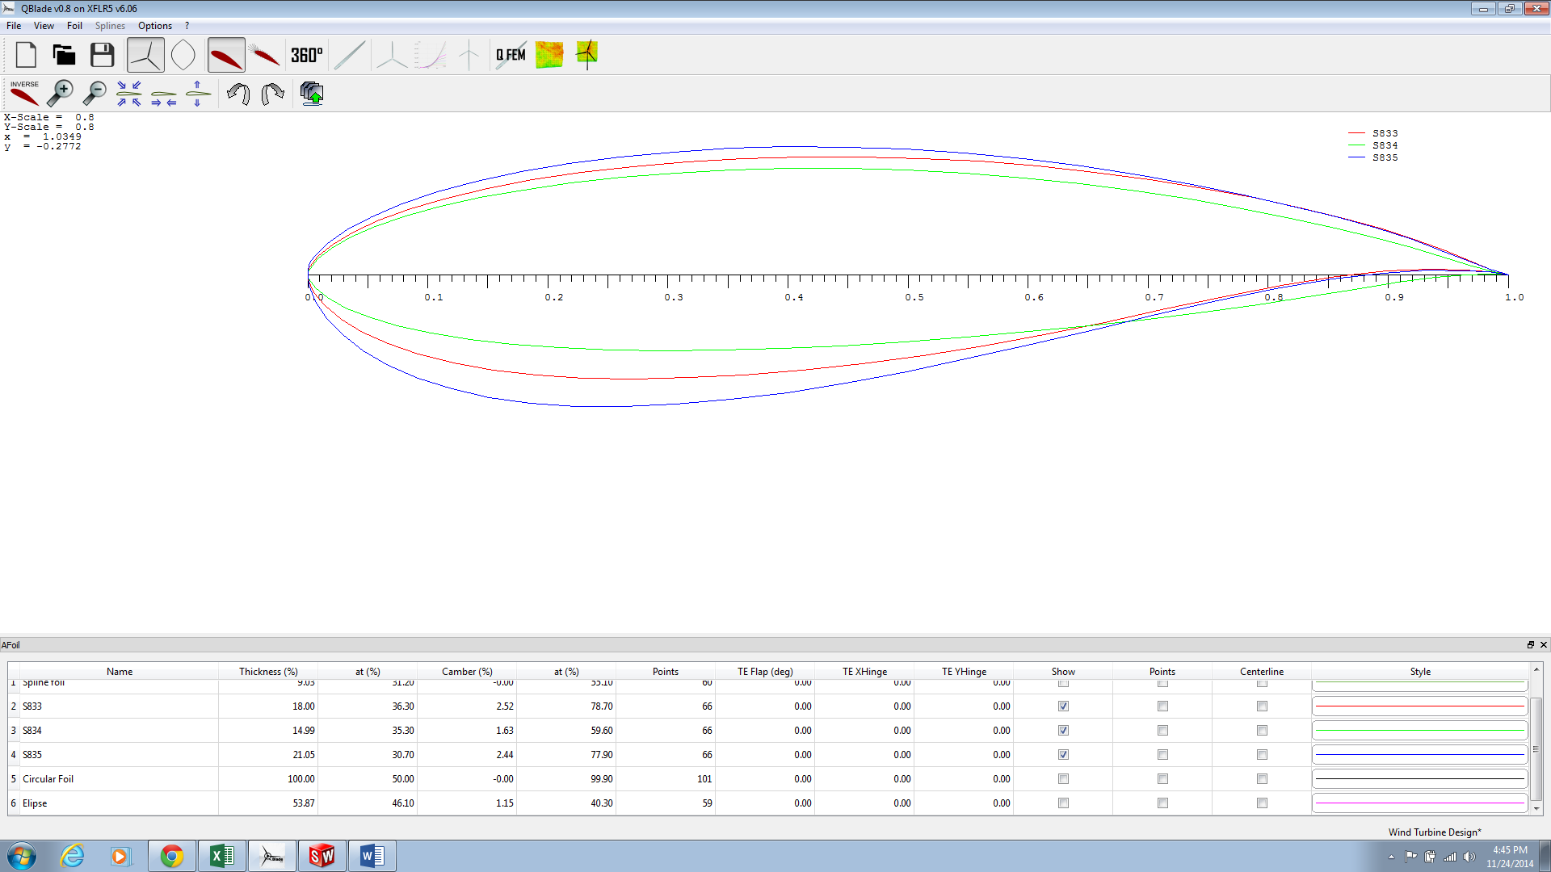

Next we had to choose a tip-speed-ratio (TSR) to design for. Our research indicated that a TSR between 5 and 7 offered the highest performance for a 3-bladed turbine design. After using Q-Blade to calculate the Cp of each design, we chose to go with a designed TSR of 6 based on its performance, ease of manufacturing, and thicker profile to reduce deflection (Figure 2).

Figure 2

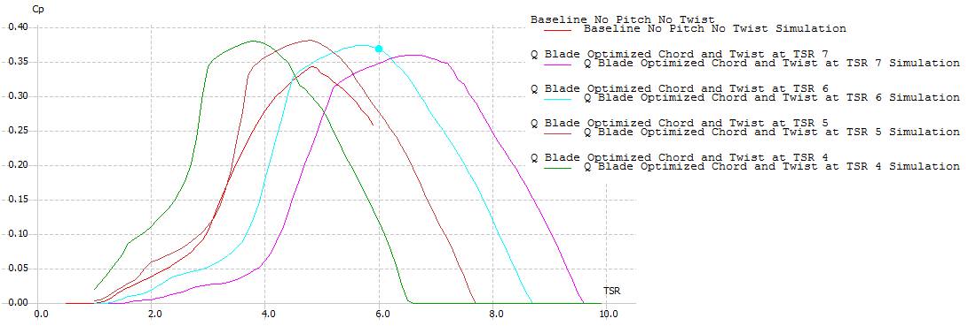

**Generator Constraints**

As part of this process we had concerns about the generator selection since designing for a higher TSR would increase our designed RPM and lower our generated torque. A higher TSR makes it more likely that the RPM limit may occur at lower wind speeds, which would make our peak power production occur early (Table 1).

|  |  |  |  |  |  |  |  |
| --- | --- | --- | --- | --- | --- | --- | --- |
| *Table 1* |  |  |  |  |  |  |  |
|  |  | Tip Speed Ratios | | | |  |  |
| Generator RPM | | 4 | 5 | 6 | 7 | radius = | 0.19 |
| 4000 | | 19.89675 | 15.9174 | 13.2645 | 11.36957 | Values in table show max wind speed (m/s) for generator max rpm. | |
| 4500 | | 22.38385 | 17.90708 | 14.92257 | 12.79077 |
| 5000 | | 24.87094 | 19.89675 | 16.58063 | 14.21197 |
| 5500 | | 27.35804 | 21.88643 | 18.23869 | 15.63316 |

We expressed our concern over the generator selection to the electrical team and they suggested we choose a generator to meet our needs. We decided to go with the generator with a lower cut-in torque that still met the desired power output and had a good RPM range so we wouldn’t reach max power prematurely.

Note: I had meant to include our generator choice here, but it wasn’t in stock and so we need to choose a different one that will then go here.

**Hand Calculation Checks**

It was important from the beginning to gain a better understanding of the models and assumptions behind them for our analysis of the wind turbine blade design. It was difficult to find an approach that worked with our data limitations, but after extensive research we found a Blade Element Momentum Theory approach that didn’t require data we didn’t have. We wanted to approach the solution given by Q-Blade as well as we could so we investigated using correction factors we knew the program used. We found an equation for the Prandtl tip loss factor, but had not arrived at one for the root loss. A mixture of approaches from different sources was used to derive the calculations we built into a spreadsheet to give us the values we were interested in: section twist angle, section chord length, section lift, and section drag. The equations we used in our spreadsheet are given below:

$$Section TSR \left(λ_{r,i}\right)=\frac{Designed TSR*Root}{Blade Radius}$$

$$Relative Wind Angle \left(W_{Rθ}\right)= \left(\frac{1}{3}\right)*\tan^{-1}\left(\frac{1}{λ_{r,i}}\right) (in radians)$$

$$Section Twist Angle=Relative Wind Angle-Designed Angle of Attack$$

$$Tip Loss Factor= \left(\frac{2}{π}\right)*\cos^{-1}\left(exp\left(\frac{\frac{-\# Blades}{2}*\left(1-\frac{Root}{Blade Radius}\right)}{\frac{Root}{Blade Radius}*\sin\left(W_{Rθ}\right)}\right)⁡\right)$$

$$Chord Length= \frac{8*π*Root*Tip Loss Factor*\sin\left(W_{Rθ}\right)*\left(\cos\left(W_{Rθ}\right)-λ_{r,i}*\sin\left(W_{Rθ}\right)\right)}{\# Blades* C_{l}*\left(\sin\left(W_{Rθ}\right)+λ_{r,i}*\cos\left(W_{Rθ}\right)\right)}$$

$$Relative Velocity \left(V_{R}\right)= \sqrt{{Wind Speed}^{2}+\left({ω_{max}}^{2}*{Root}^{2}\right)}$$

$$Section Lift \left(δL\right)=Chord Length*0.01*0.5*ρ_{std}*\left({V_{R}}^{2}\right)*C_{l}$$

$$Section Drag \left(δD\right)=Chord Length*0.01*0.5*ρ_{std}*\left({V_{R}}^{2}\right)*C_{d}$$

An image of part of our spreadsheet is given below in Figure 3 below. From this spreadsheet we were able to get twist, chord, lift, and drag forces to compare with Q-Blade. The force data from these hand calculations was also used for Finite Element Analysis of stresses and deflection in Solidworks.

Figure 3



Once we had these calculations done we looked at the comparison between our calculations and what Q-Blade gave us (Figure 4). We knew they wouldn’t match up exactly because our model was simpler than the model Q-Blade used and differences would propagate through the calculations. A positive difference indicates that Q-Blade had a larger value, a negative difference indicates Q-Blade had a smaller value. When we look at the differences between our calculations and Q-Blade we clearly see that the differences are largest when we switch airfoils. We see large difference jumps both when we switch from S835 to S833 and from S833 to S834. We also disregard the differences at the tip since our simple model makes that chord length zero, so we know we’ll be very different there. Interestingly our difference for the section lift and section drag are relatively constant over the root lengths. This comparison shows that although our simple model produced fairly accurate results in some cases, it requires refinement to accurately model the full range of the problem.

Figure 4



**Finite Element Analysis Preparation**

Once we had arrived at a blade design that looked promising and had finished our hand calculations we wanted to do FEA on the design to observe any possible issues that might arrive. Here again we wanted to compare the two simulation software packages we were using. However, to work with Solidworks we had to move our model from Q-Blade to Solidworks. After looking at the options I decided to build a spreadsheet to scale, rotate, and center an airfoil in order to import the curve coordinates into Solidworks (Figure 5). The goal was to loft along a set of profiles that would define the change in twist angle, chord length, and airfoil selection as we moved along the blade.

Figure 5



Once we had defined all the different airfoil sections and imported it into Solidworks we had the “skeleton” of the blade (Figure 6).

Figure 6

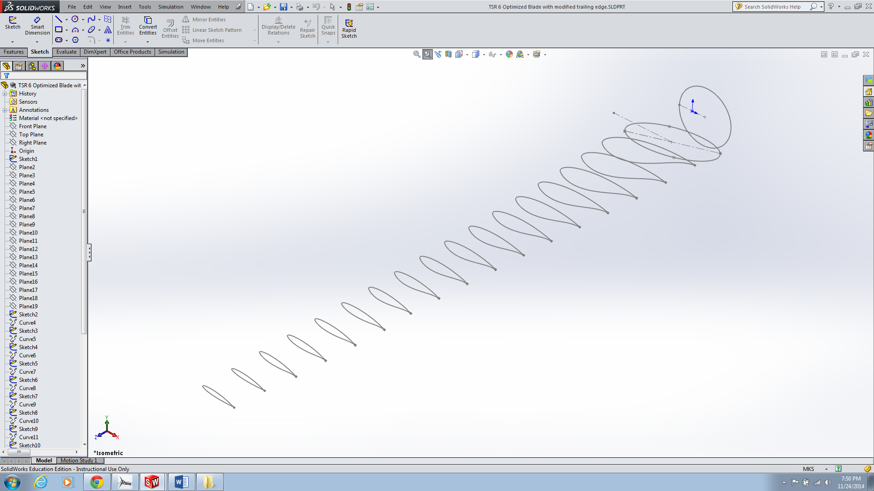

Next we would loft the blade along each of these profiles. There were many issues with the loft we didn’t foresee, it proved extremely difficult to precisely control the loft along the separate profiles. We ended up with “creases” and un-desired twist that we did our best to minimize (Figures 7 & 8).

Figure 7

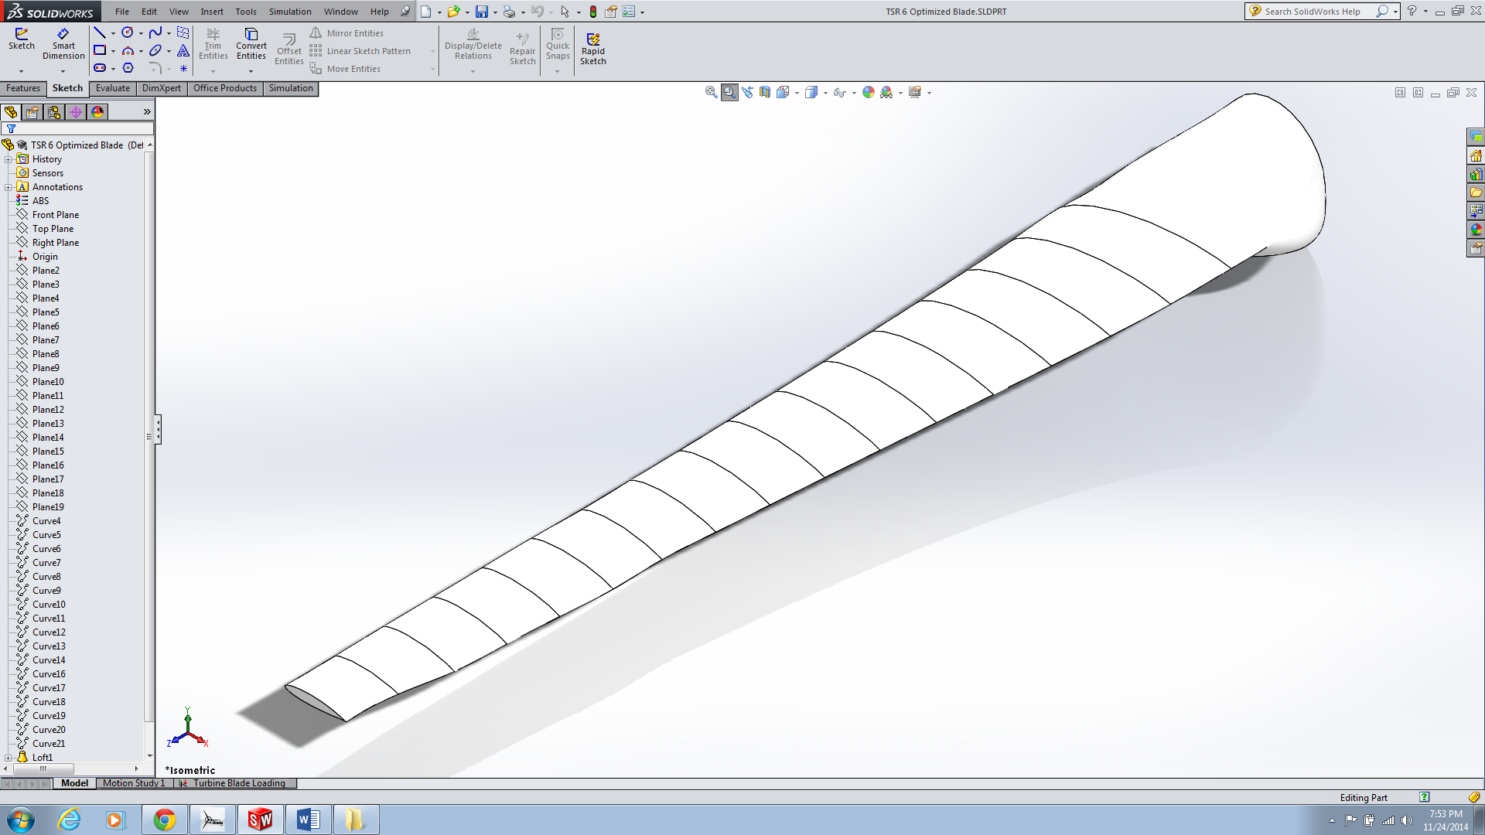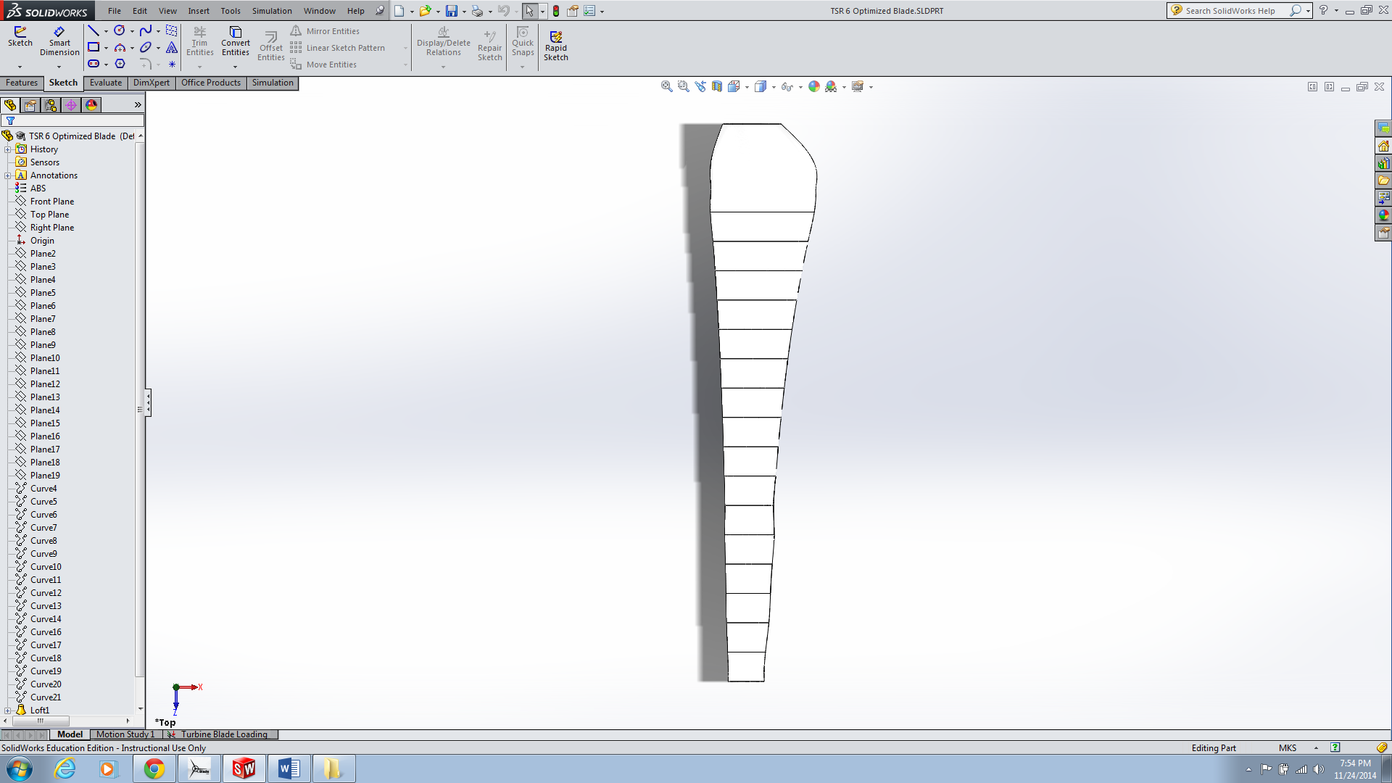

Figure 8

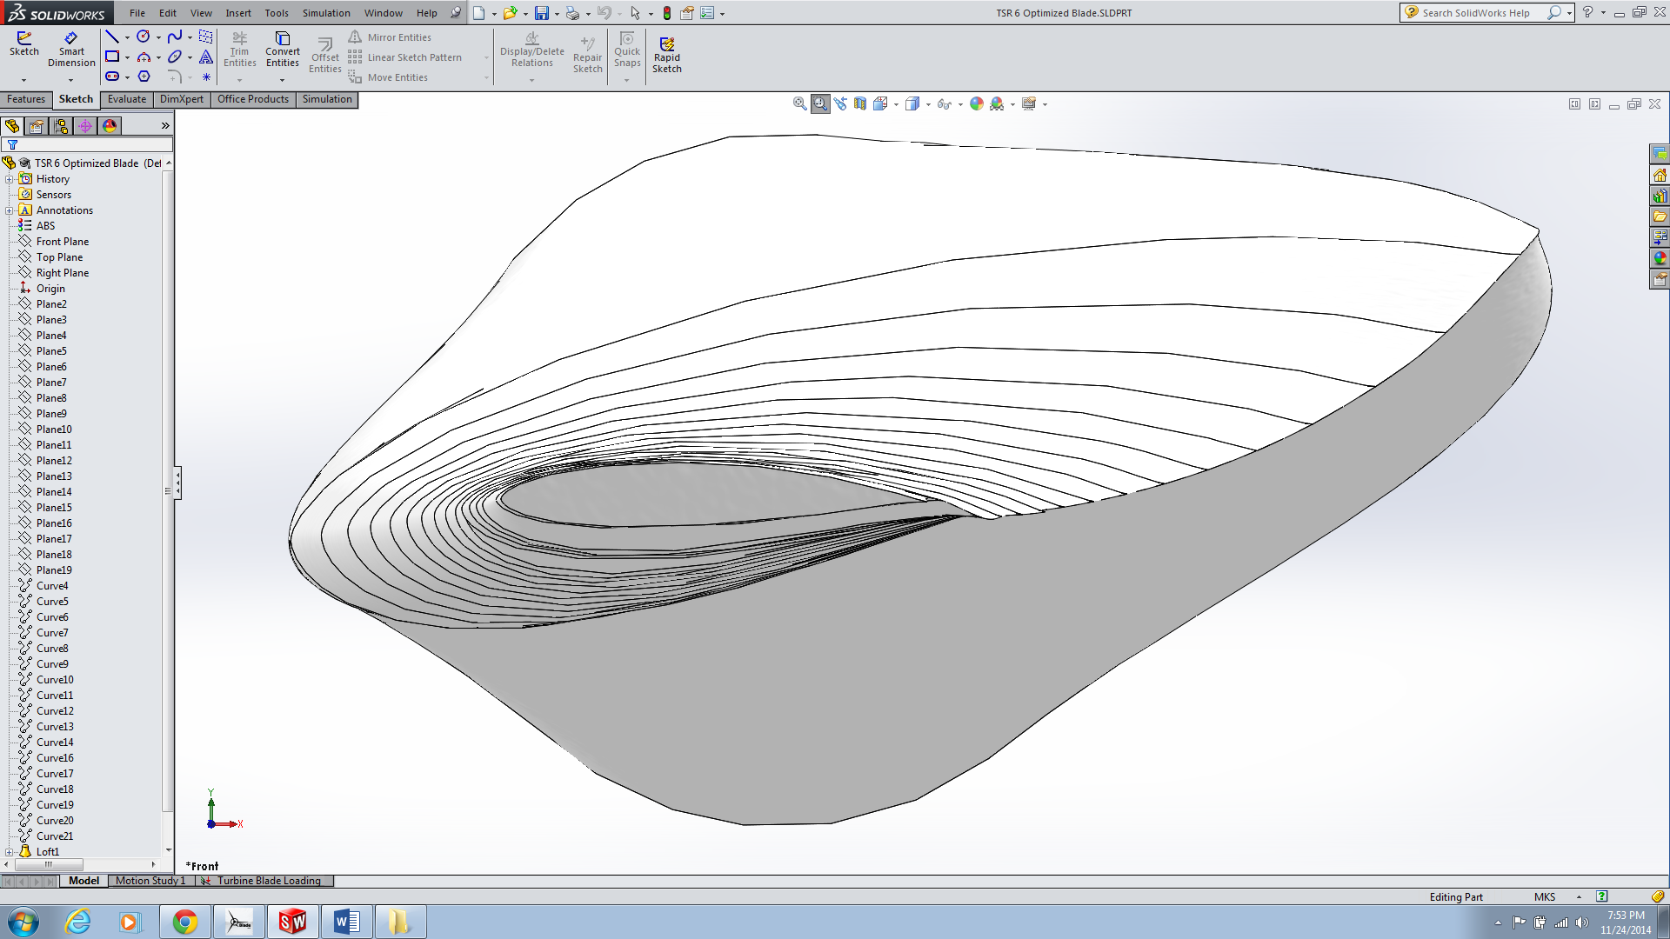

Now that the model, although imperfect, was in Solidworks we could start with our FEA analysis. I applied the 33 loads calculated in our hand calculations and fixed the end where we would attach the blade to our hub (Figure 9).

Figure 9

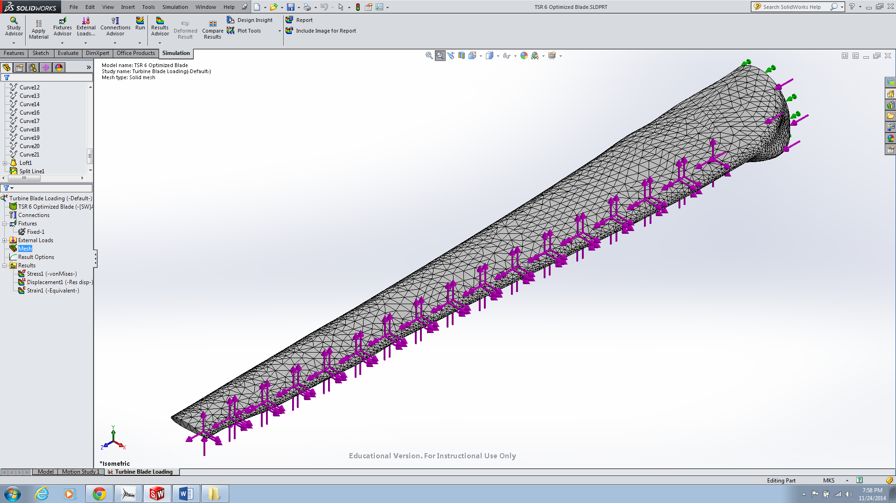

**Finite Element Analysis Results**

There are two results from the FEA we’re interested at looking at and comparing between our two simulation programs. First we’ll look at Solidwork’s results (Figure 10 & 11).

Figure 10

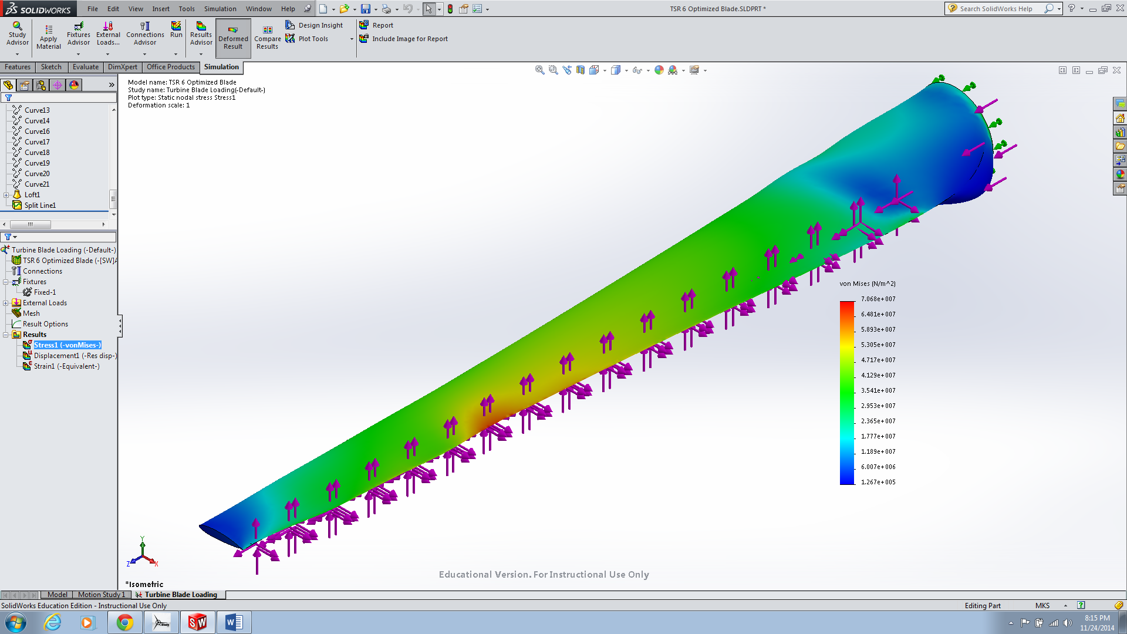

Figure 11

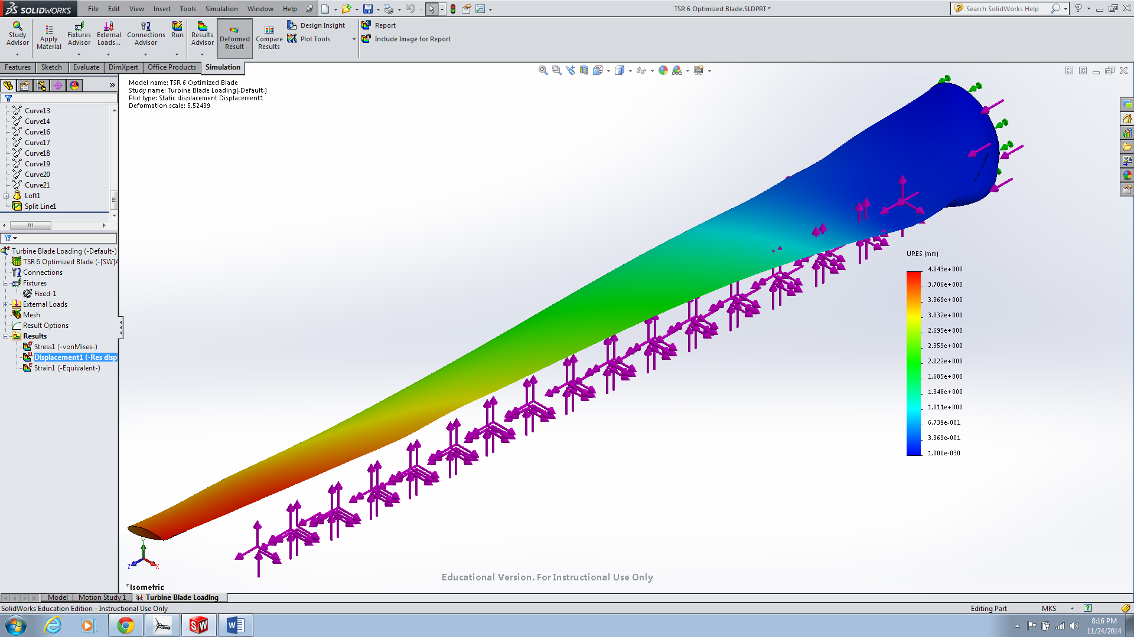

Now we want to look at Q-Blade’s analysis and then compare. We set the simulation to run at 5000 RPM with a windspeed of 17 m/s, input the material properties given by Solidworks for ABS Plastic (E & ρ), and define the material as solid with no spar. Q-Blade gives the stress and deflection on one screen (Figure 12).

Figure 12

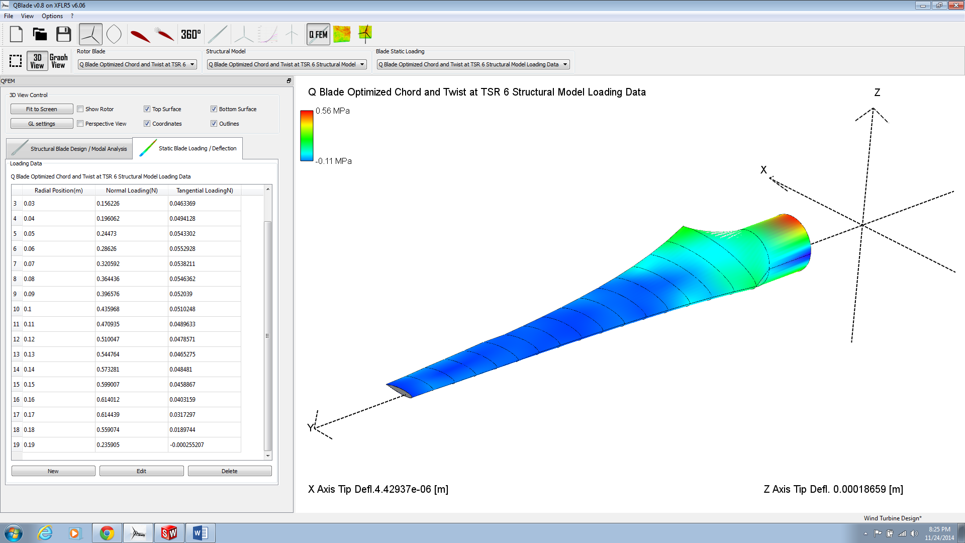

When we compare the two they are very different. Q-Blade predicts the greatest stress to be at where the blade connects to the hub (which matches our intuition) and Solidworks shows the highest stress occurring on the trailing edge around 2/3rds down the blade. Solidworks also shows a much higher value for the highest stress of 7.068 e7 Pa compared to Q-Blade’s 5.6 e5 Pa. Solidworks shows that the blade lengthens and twists counterclockwise under the load with a maximum deflection of 4 mm at the trailing edge of the tip, while Q-Blade predicts that the tip deflects very minimally in the X & Z directions (the program doesn’t give Y deflection).

These results aren’t incredibly surprising though given the difficulty in obtaining an accurate Solidworks models (creases and twists will act as concentration points for stress) and the differences we observed in our hand calculations and the Q-Blade calculated data. When we look at the loading scenario for the blade Q-Blade’s results make more sense in our experience and are also reflected in the choice of a thicker airfoil to reinforce the root of the blade that we see in industry.

**Q-Blade Modal Analysis**

As part of our analysis we were concerned that deflection could allow for an oscillation that could grow at specific rotation frequencies. We were excited to see that Q-Blade analyzed this failure mode internally since rotational buckling was outside our expertise in Solidworks analysis. With a TSR of 6 and a wind speed of 17 m/s, assuming no losses we would be spinning at 5126.464 RPM. That gives a rotational speed of 85.441 Hz to compare with the Q-Blade modal failure numbers given below (Figures 13 & 14). Note: Deformation exaggerated for demonstration purposes.

Figure 13

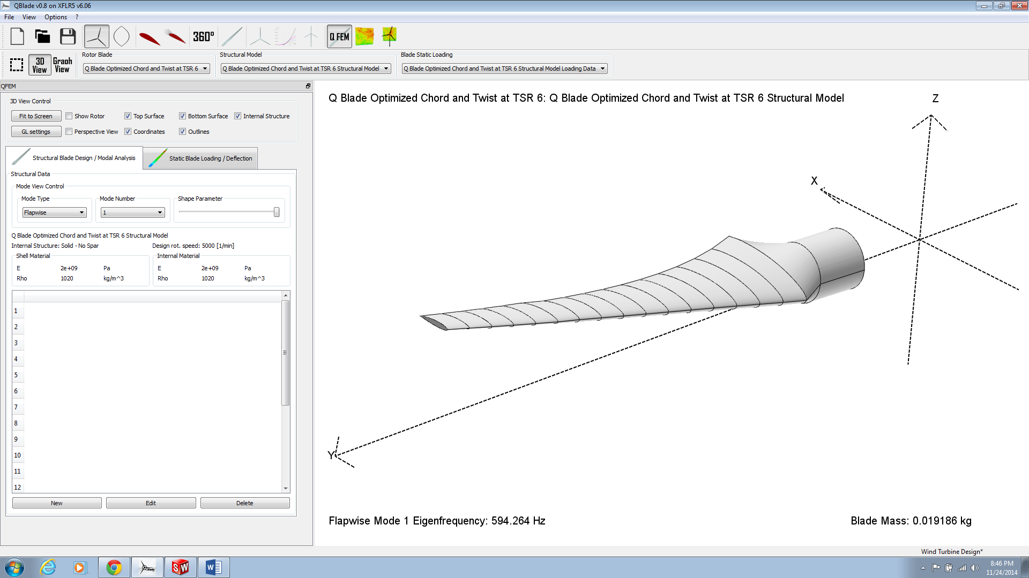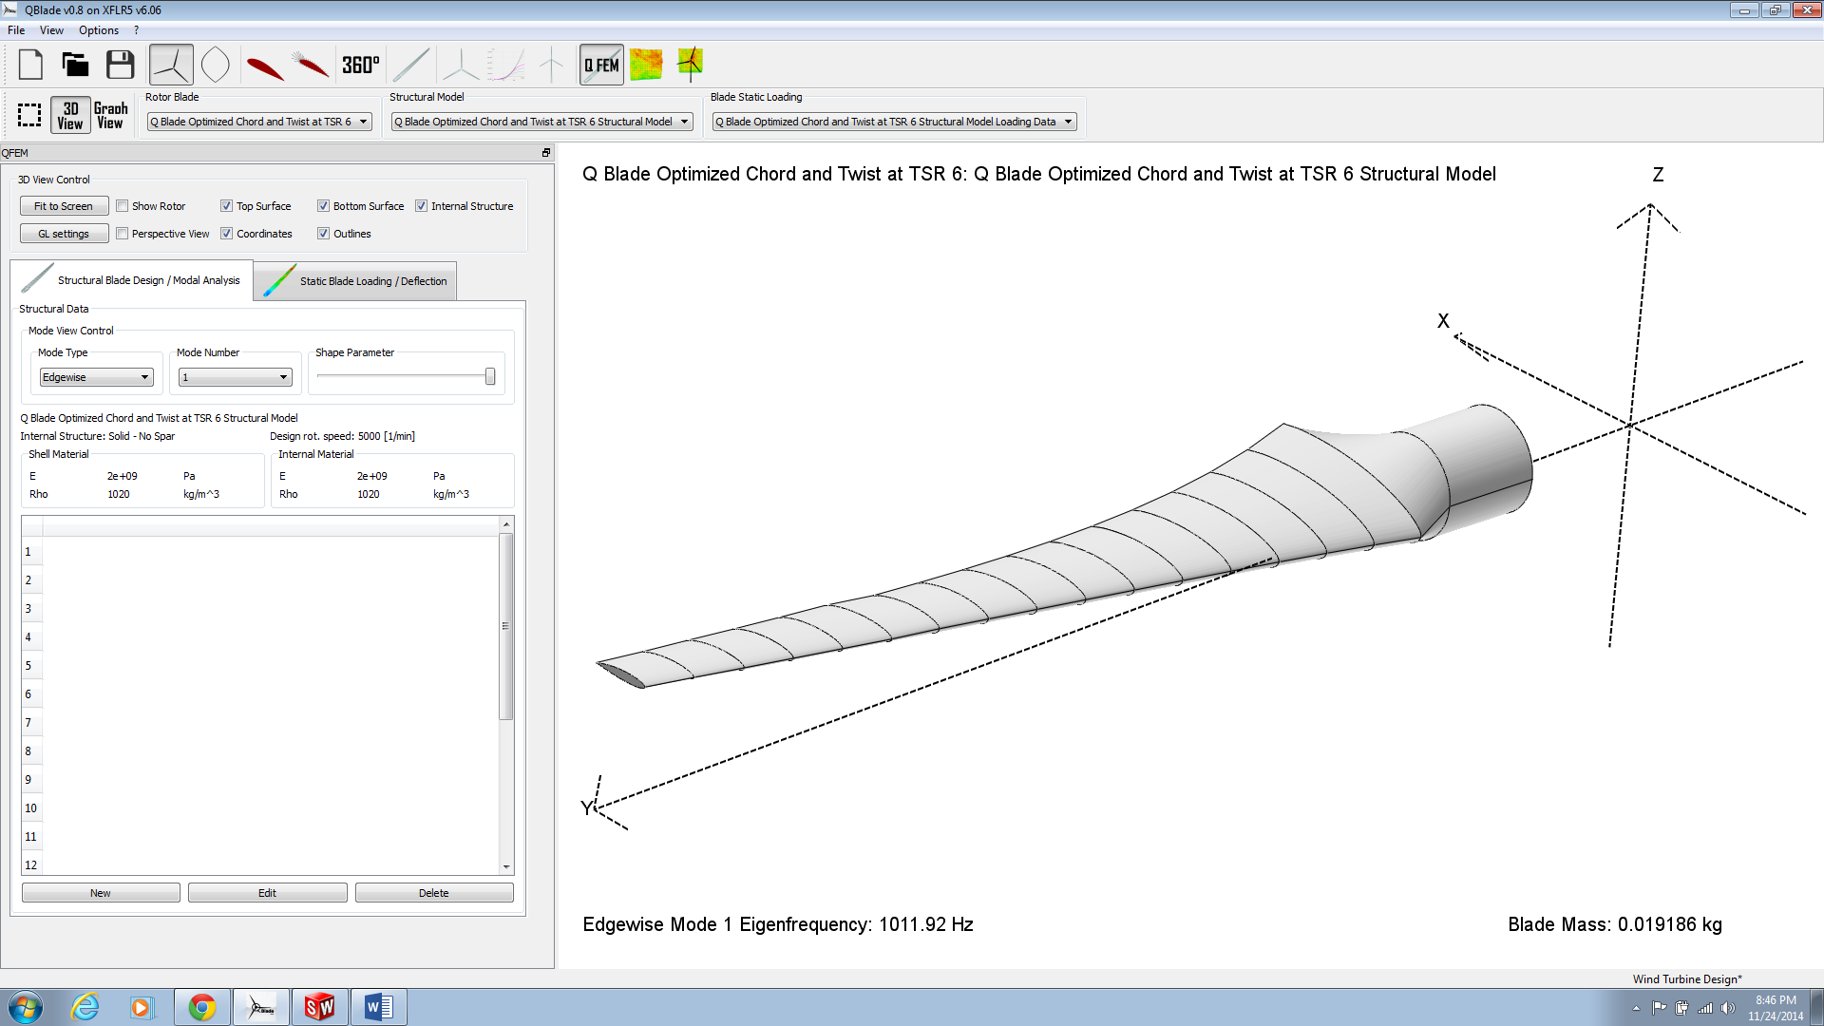

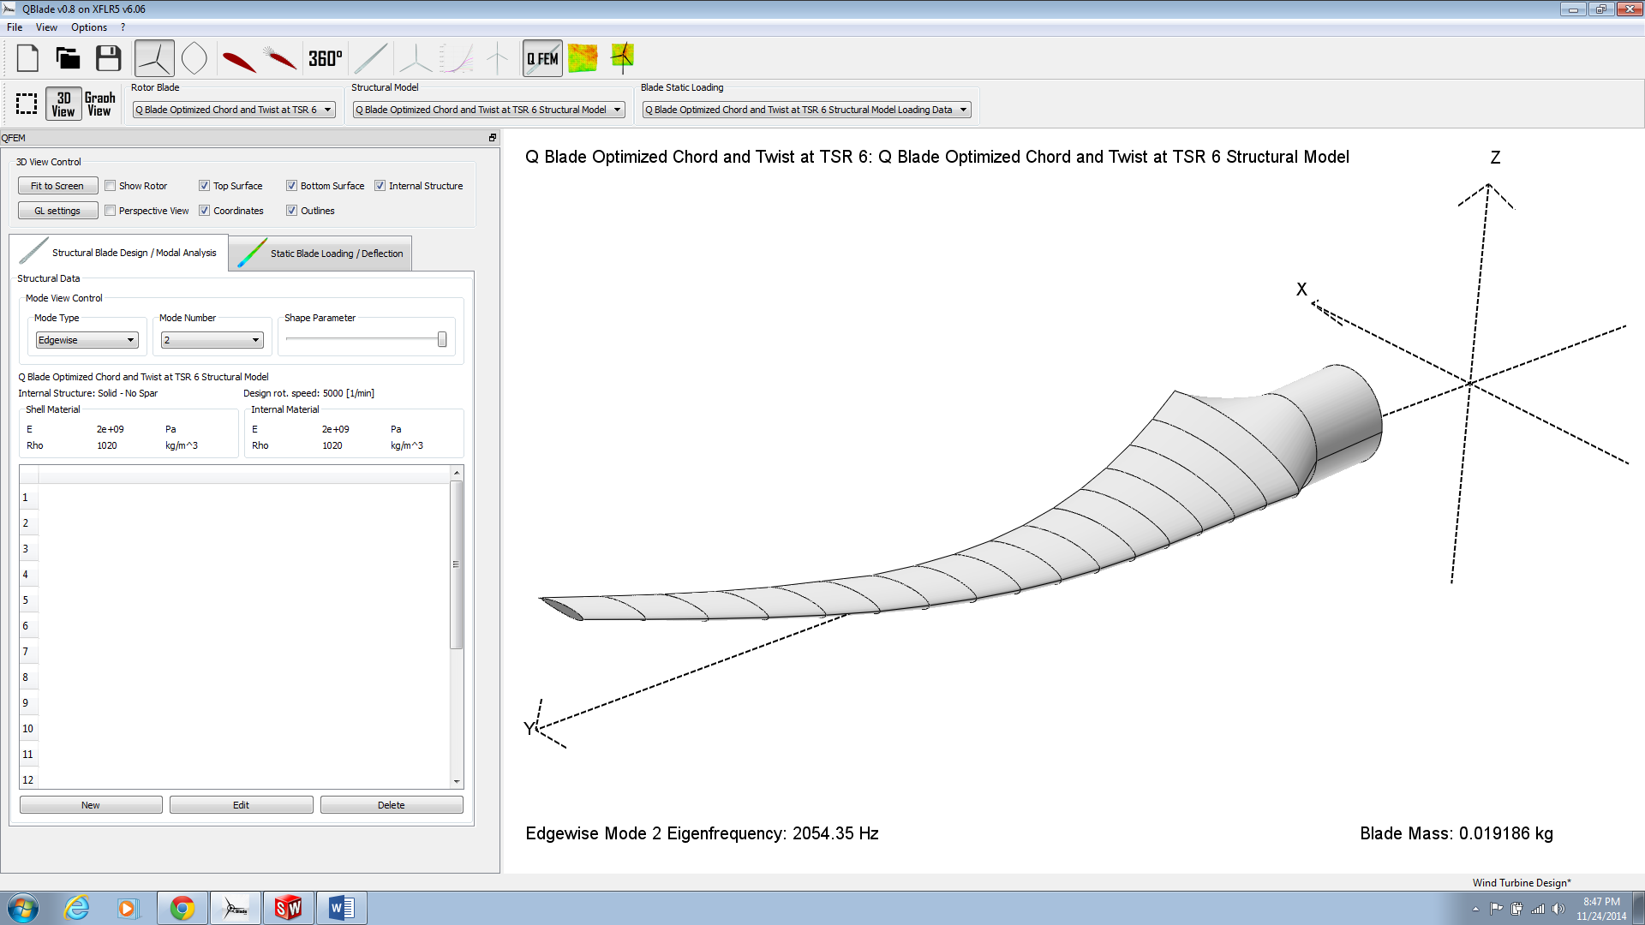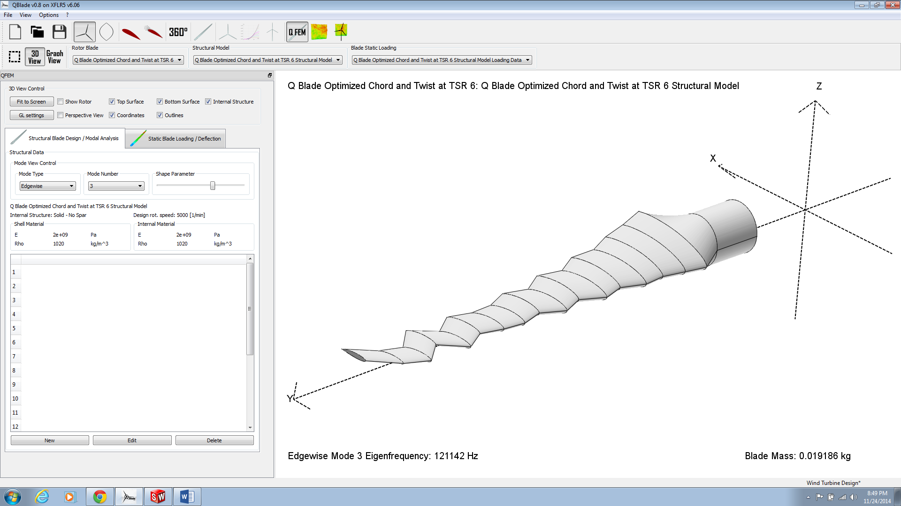

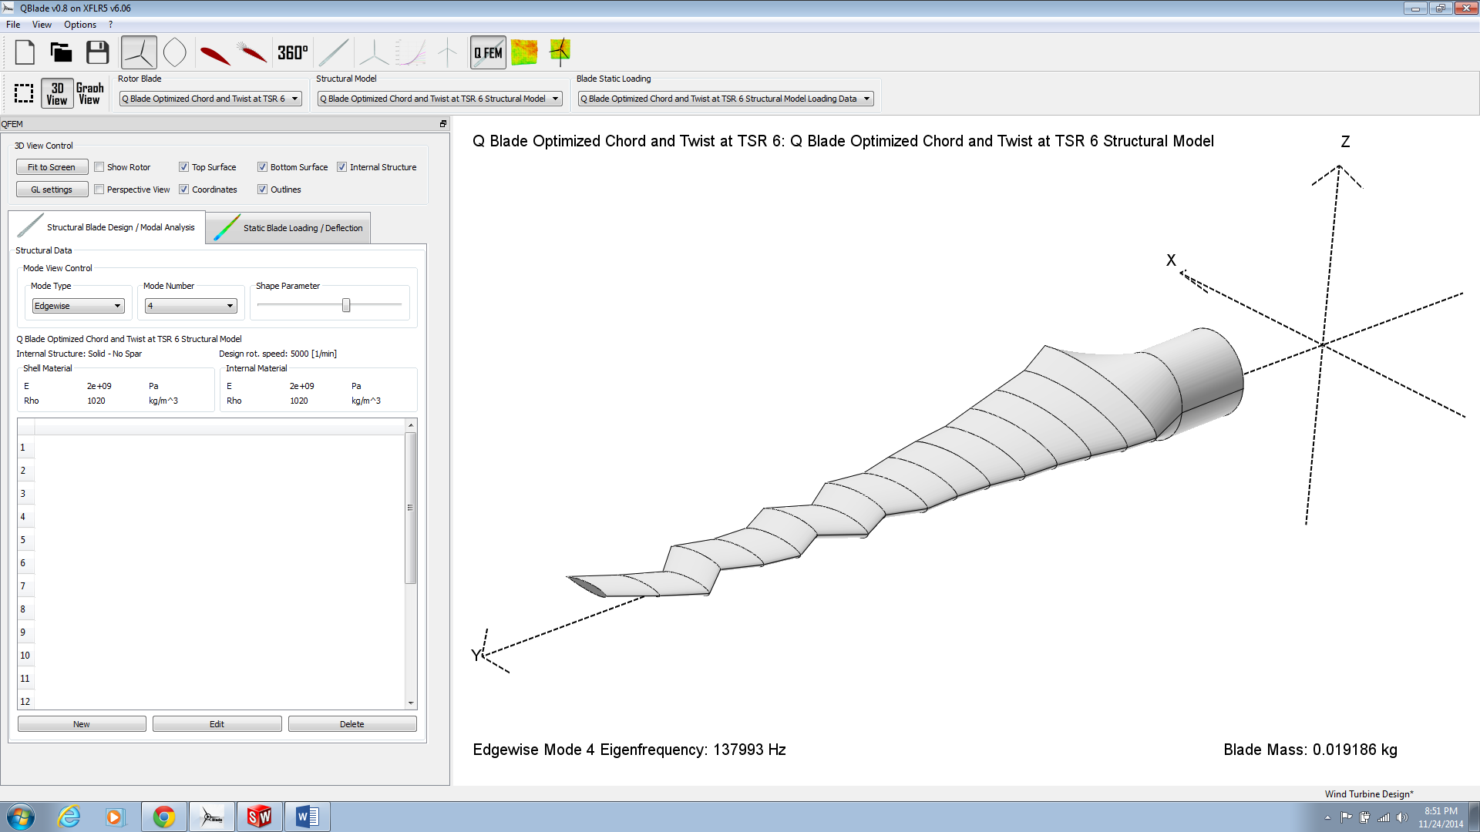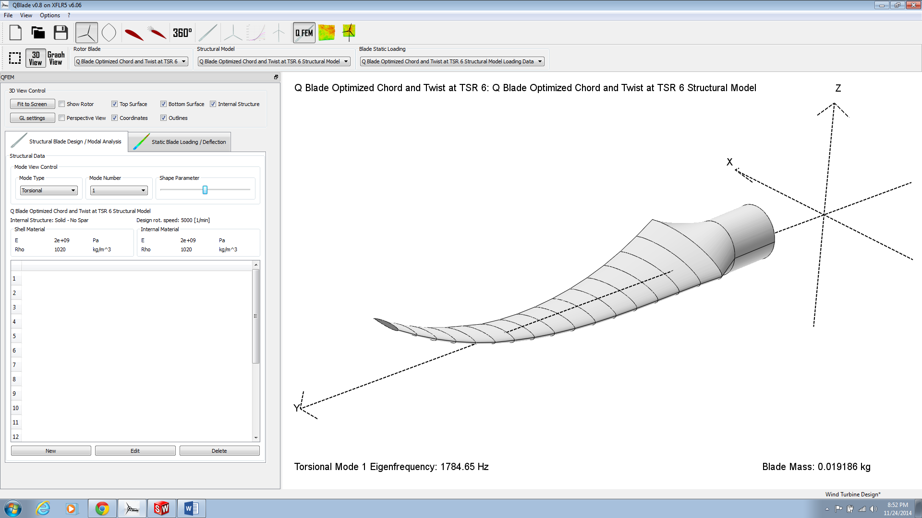

Figure 14

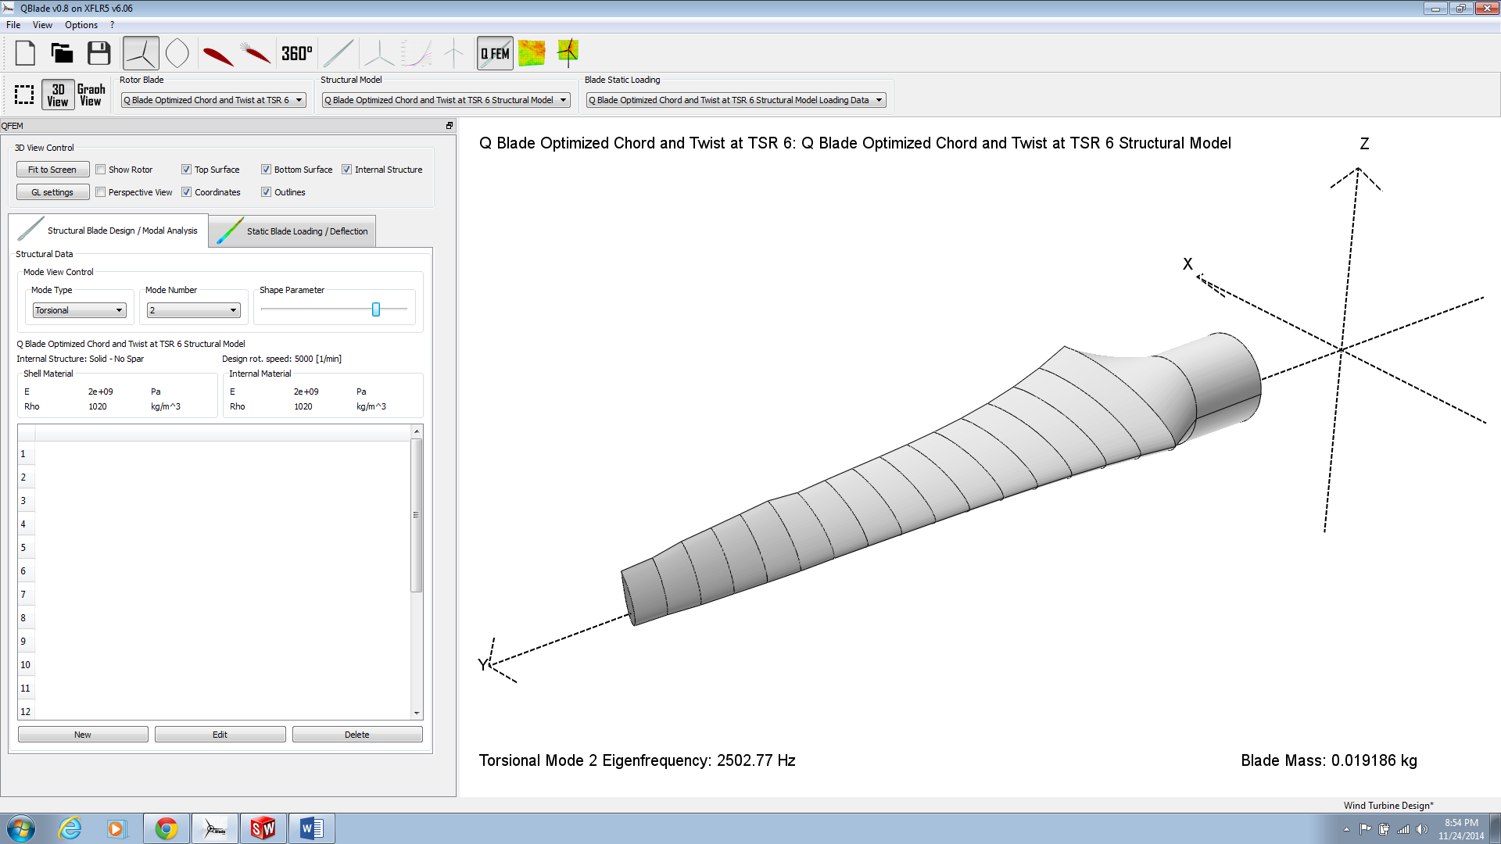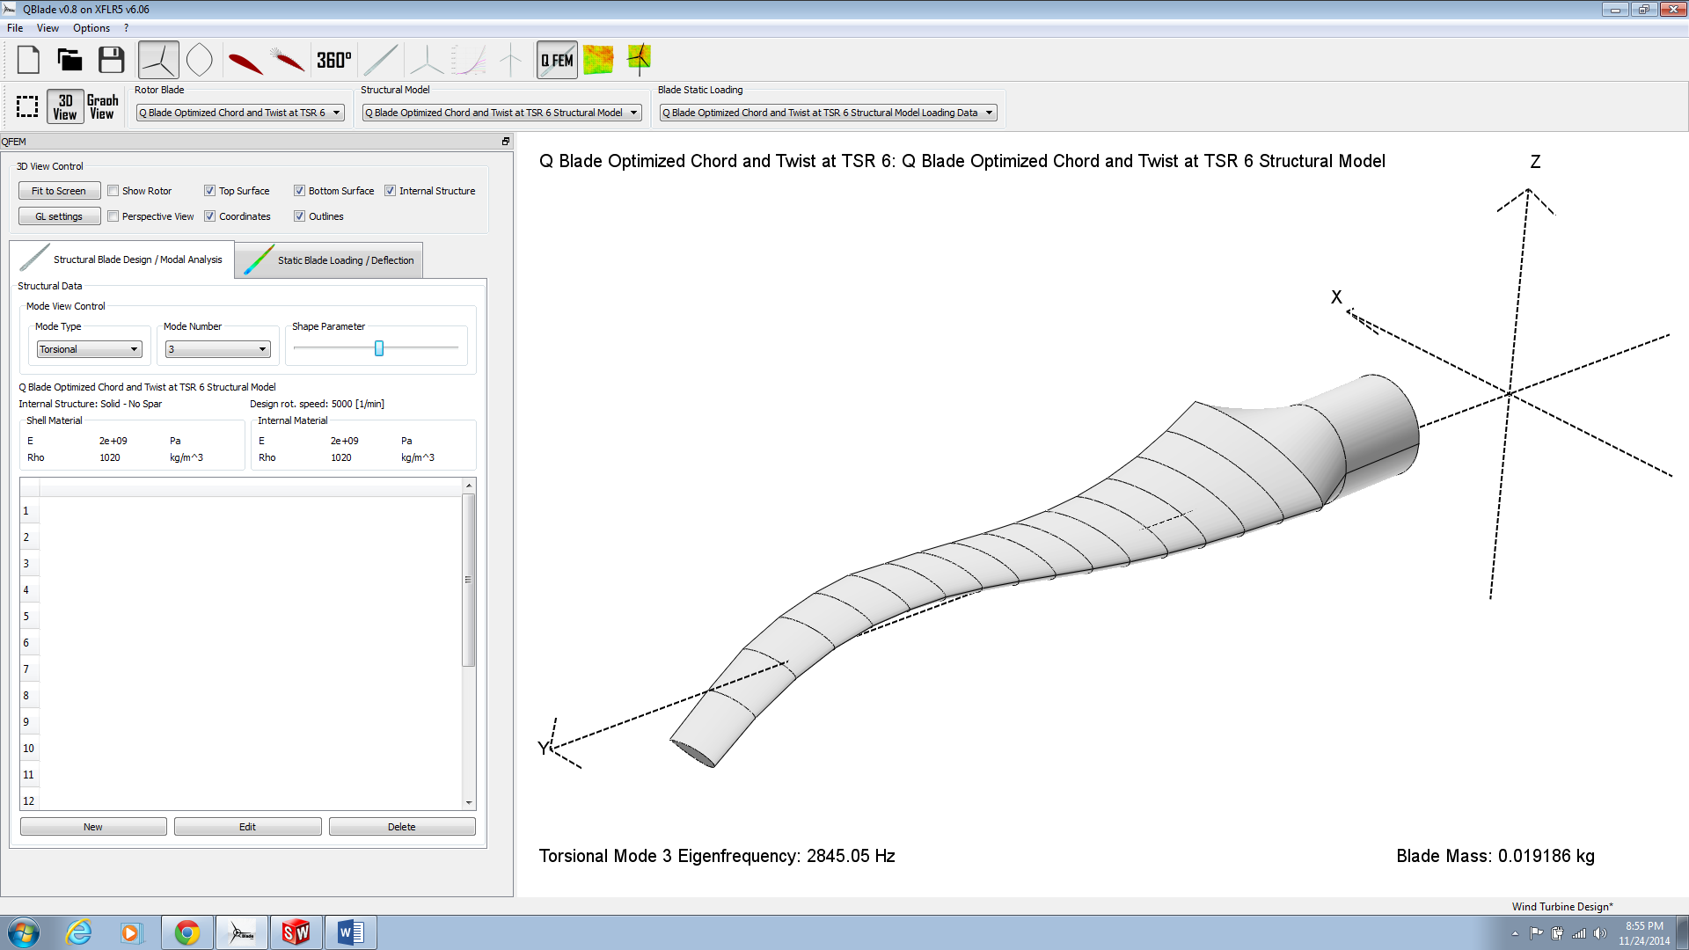

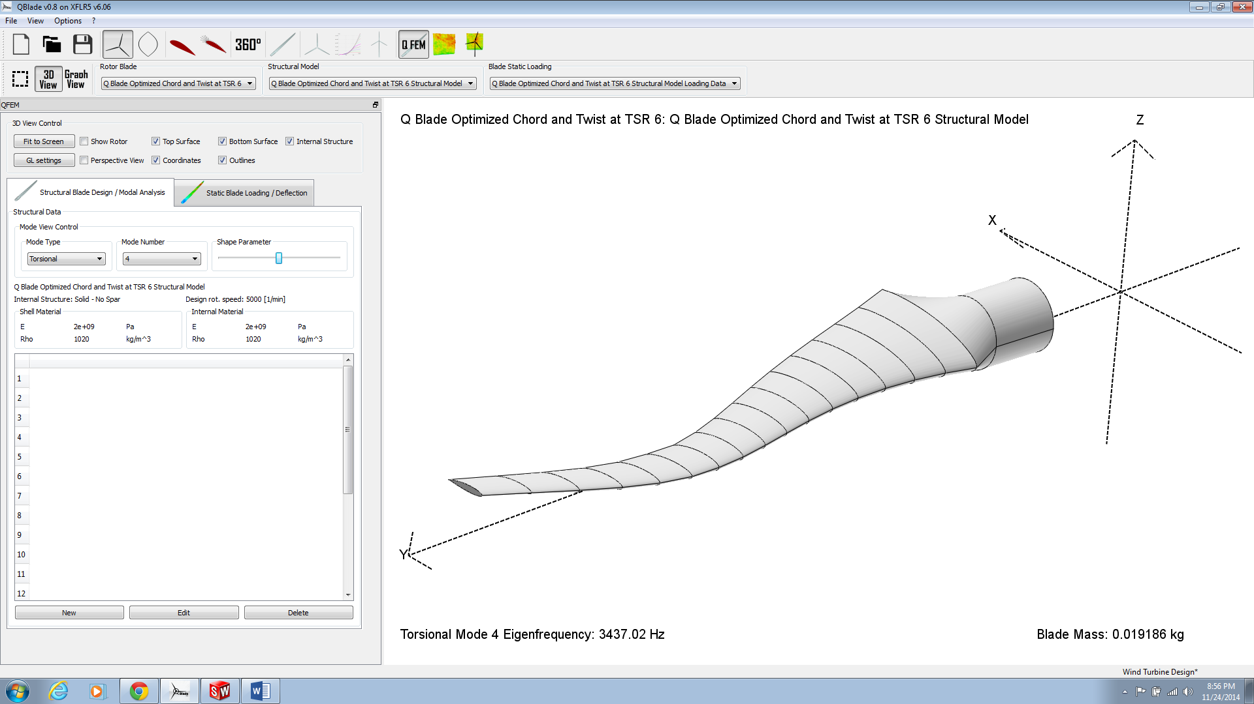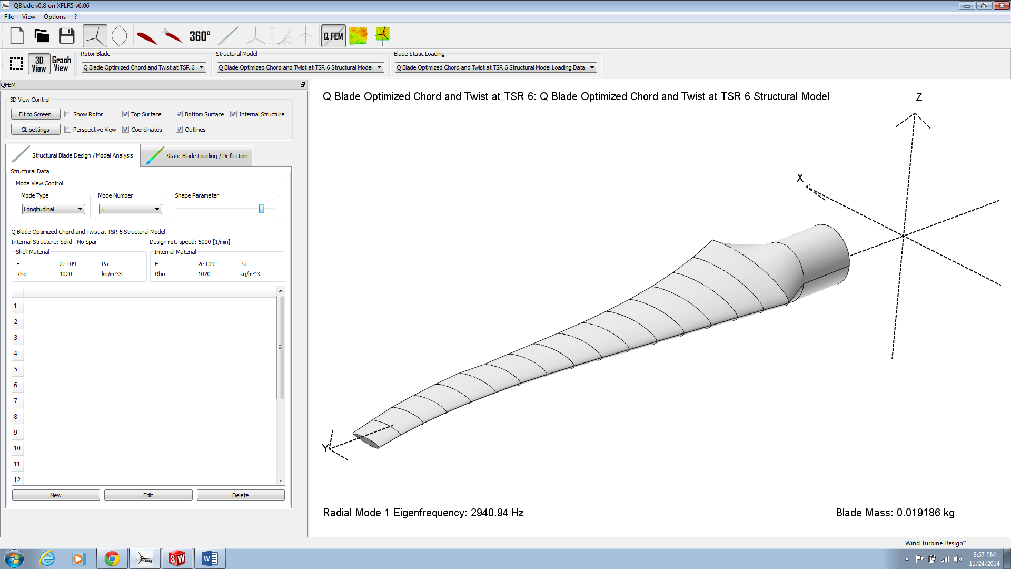

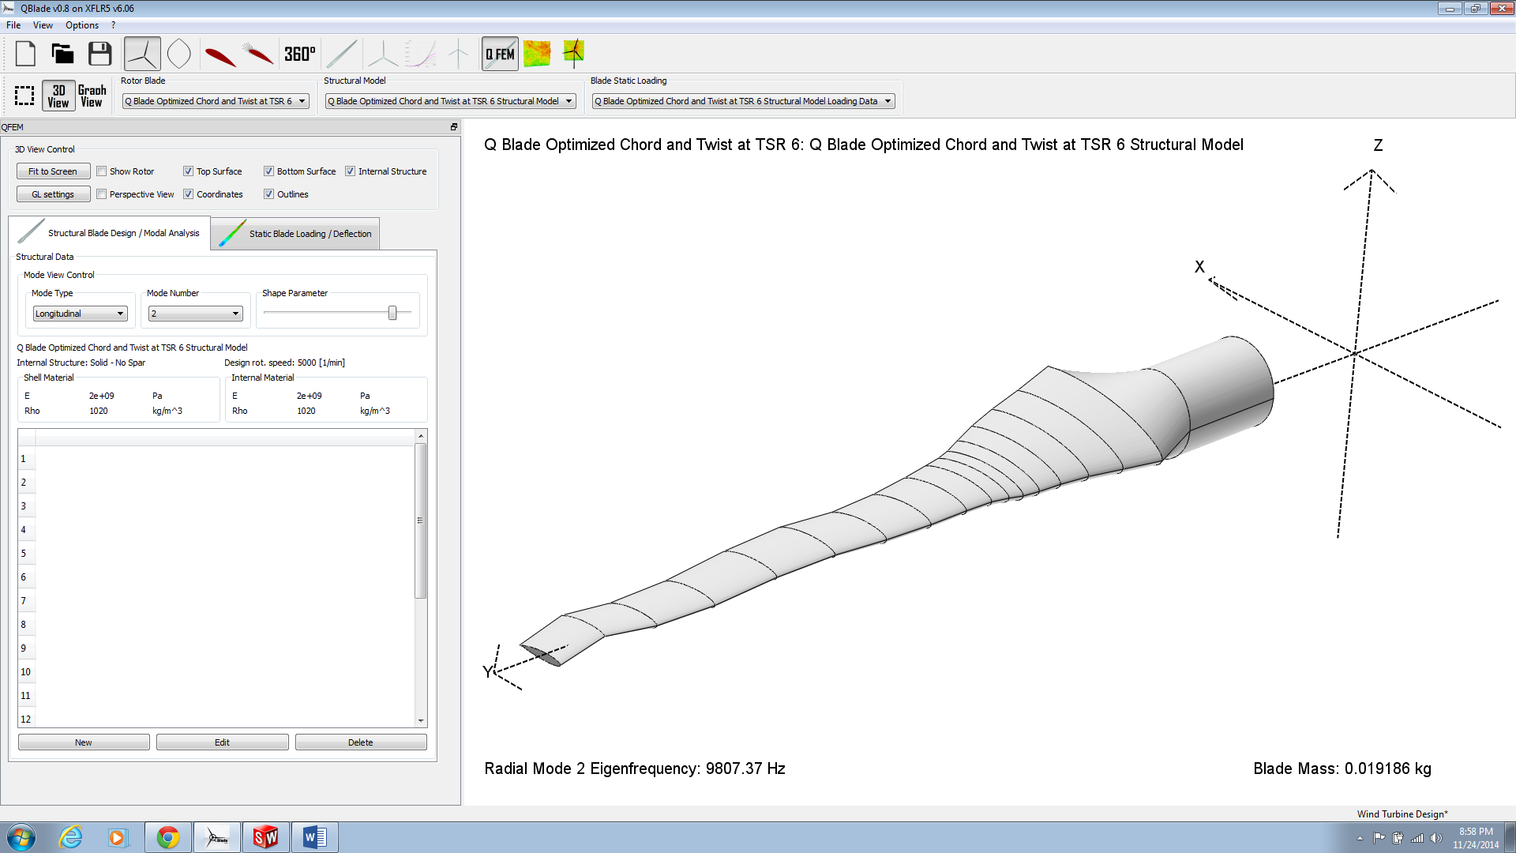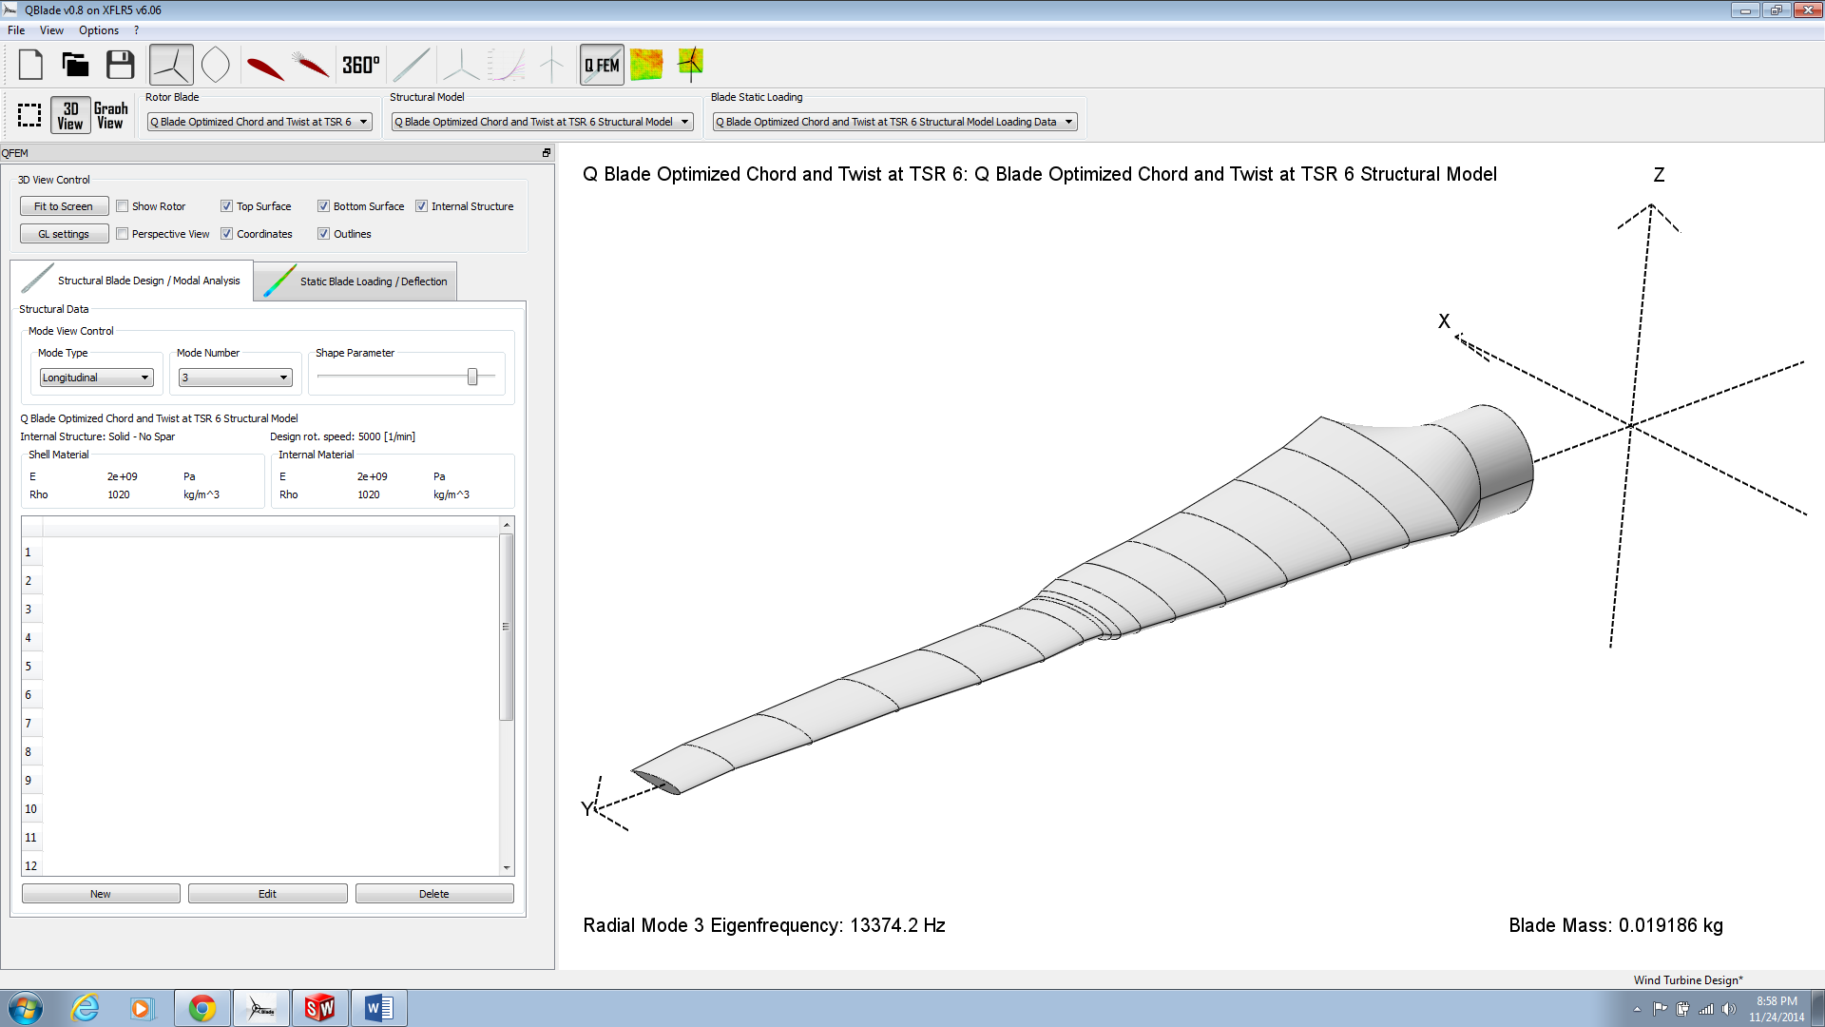

**Simulation Conclusions**

The majority of the blade design team’s time has been spent on simulations during this design process. Setting up and observing the simulations has increased our understanding of the problem and the physics behind it. It also has increased our confidence in the performance of our design. Based on our simulation results we believe that our blade design is ready to be printed for real world testing.

To move forward we would like to have real world data to compare with our simulation results to further substantiate their findings. Further investigation of more accurate hand calculations and a better solution for modeling the blade design in Solidworks would also be advantageous. At this point we also have not implemented our blade design into FAST for further analysis.

Our plan moving forward is to work towards real world testing while preparing the FAST simulation. Once we have the results from those two tests we can iterate our design as needed. Using those two results and further research into more accurate hand calculations we can refine our understanding and model to better fit what we see in the real world testing.

Note: Probably needs work, but I’ve been working on it for about 12 hours straight and I’m out of ideas.